**Daily Scrum or Standup Meeting**

Team name: Team 08

Scrum Master: Tristan Thomas

Date: Nov 6

|  |  |  |  |
| --- | --- | --- | --- |
| **Team Member** | **What did you do since the last Scrum?** | **What do you plan to do before the next scrum?** | **What obstacles do you have?** |
| Hannah Howell | * linked everything to the home page properly | * add ability to add local code to add auction | * Dynamic Programming! |
| Garrett Johnson | * Finally finished auction creation task. | * Start on live auction item detail page. | * Other final projects |
| Zion Steiner | * I merged a few branches and fixed some conflicts. | * I might start working on my task for this week, but I might not be able to get to it until this weekend | * Dynamic programming homework |
| Tristan Thomas | * Got Item view page working and editable on front end | * figure out backend for editing items | * So much other homework |
| N/A |  |  |  |

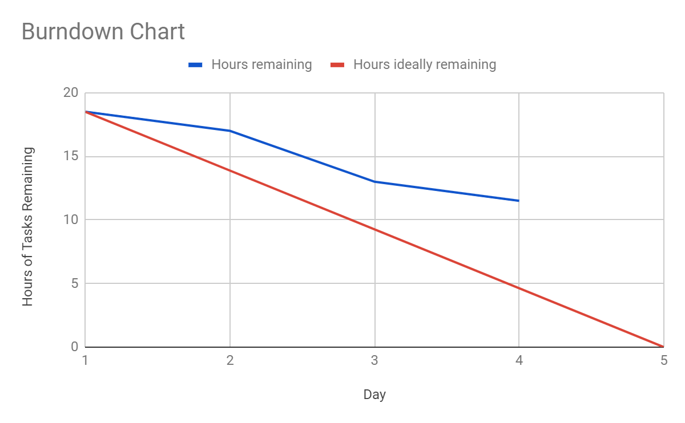

# Screenshot of your project board

